常用分布族

Z Liangliang

2019/9/14

## Gamma分布族

The gamma distribution is a flexible distribution that may offer a good fit to some sets of life data. Sometimes called the Erlang distribution, the gamma distribution has applications in Bayesian analysis as a prior distribution, and it is also commonly used in queueing theory.

The pdf of the gamma distribution is given by:

### 图像性质

**概率密度函数**

set.seed(1)  
x <- seq(0,5,by=0.1)  
y <- dgamma(x,1,2)  
plot(x, y, main="the Gamma Density Distribution",xlim = c(0,4),ylim = c(0,2), col = "red", type="l", lwd=2)  
lines(x,dgamma(x,0.5,2),col = "green" )  
lines(x,dgamma(x,1.7,2),col = "black" )  
lines(x,dgamma(x,3,2),col = "blue" )  
legend("topright",legend = paste("shape = ",c(1,0.5,1.7,3),"scale = ",c(2,2,2,2)),lwd = 1, col = c("red", "green","black","blue" ))

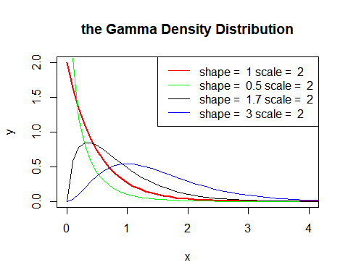

**分布函数**

set.seed(1)  
x <- seq(0,10,by=0.1)  
y <- pgamma(x,1,2)  
plot(x, y, main="the Gamma Cumulative Distribution",xlim = c(0,3),ylim = c(0,2), col = "red", type="l", lwd=2)  
lines(x,dgamma(x,0.5,2),col = "green" )  
lines(x,dgamma(x,1.7,2),col = "black" )  
lines(x,dgamma(x,3,2),col = "blue" )  
legend("topright",legend = paste("shape = ",c(1,0.5,1.7,3),"scale = ",c(2,2,2,2)),lwd = 1, col = c("red", "green","black","blue" ))

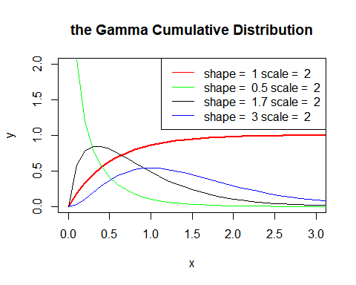

## Beta分布族

### 图像性质

set.seed(1)  
x <- seq(0,5,by=0.1)  
y <- dbeta(x,2,2)  
plot(x, y, main="the Beta Density Distribution",xlim = c(0,1),ylim = c(0,2), col = "red", type="l", lwd=2)  
lines(x,dbeta(x,0.5,0.5),col = "green" )  
lines(x,dbeta(x,1.7,2),col = "black" )  
lines(x,dbeta(x,1,1),col = "blue" )  
legend("topright",legend = paste("shape = ",c(2,0.5,1.7,1),"scale = ",c(2,0.5,2,1)),lwd = 1, col = c("red", "green","black","blue" ))

